Q1. Total number of employees in an organization.

Ans1: Hit a Get Request with organization Id, it will return number of employee present in that organization. Please see below screenshot –

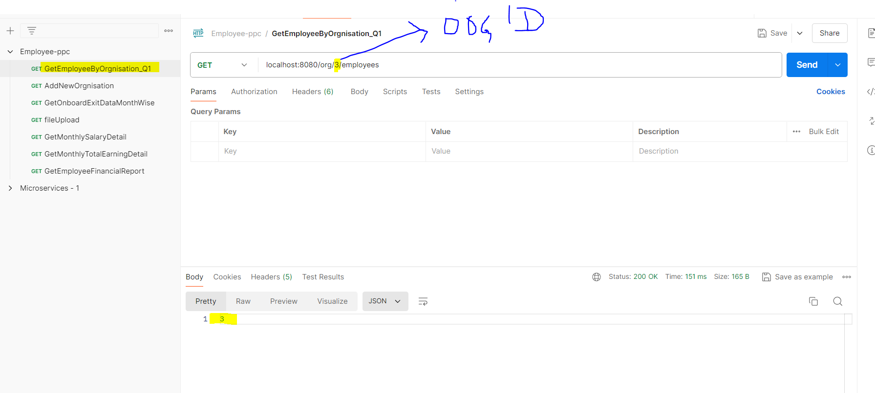

Q2. Month wise following details

Ans2. For month wise onboarding/exit data for an organization hit a GET request with organization ID. Please see below screenshot –

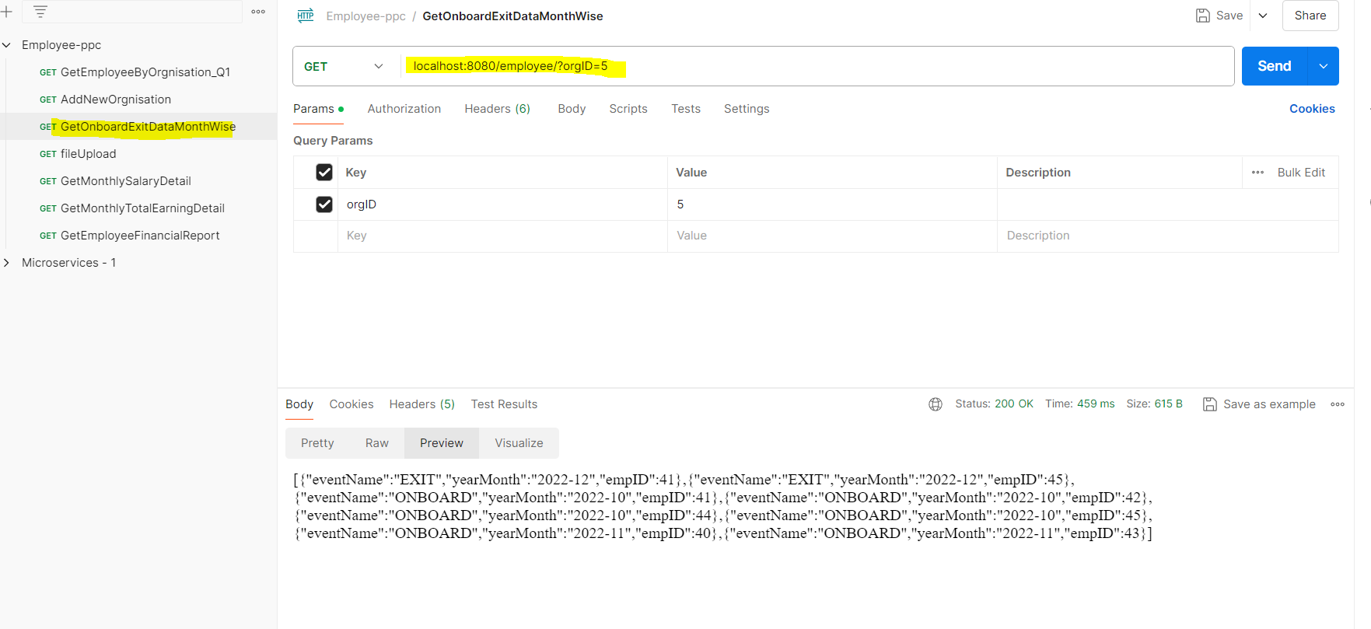

Q3. Monthly salary report in following format - Month, Total Salary, Total employees

Ans3 – For month wise salary data for an organization, hit a GET request with organization ID. Please see below screenshot

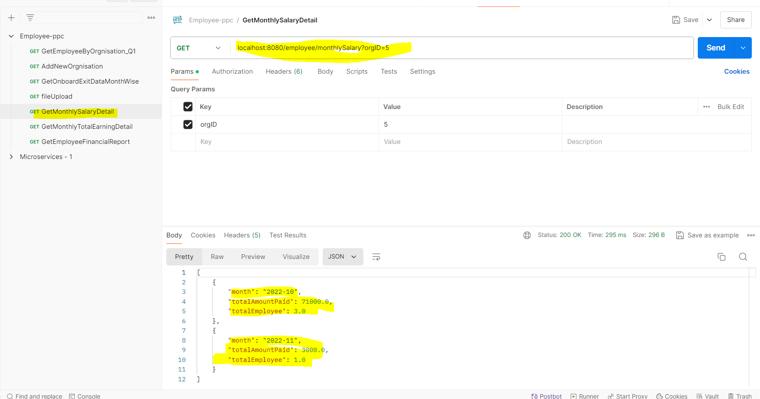

Q4. Employee wise financial report in the following format - Employee Id, Name, Surname, Total amount paid

Ans4- For Employee financial report (total amount paid to employee) data for an employees’ present in an organization, hit a GET request with organization ID. Please see below screenshot –

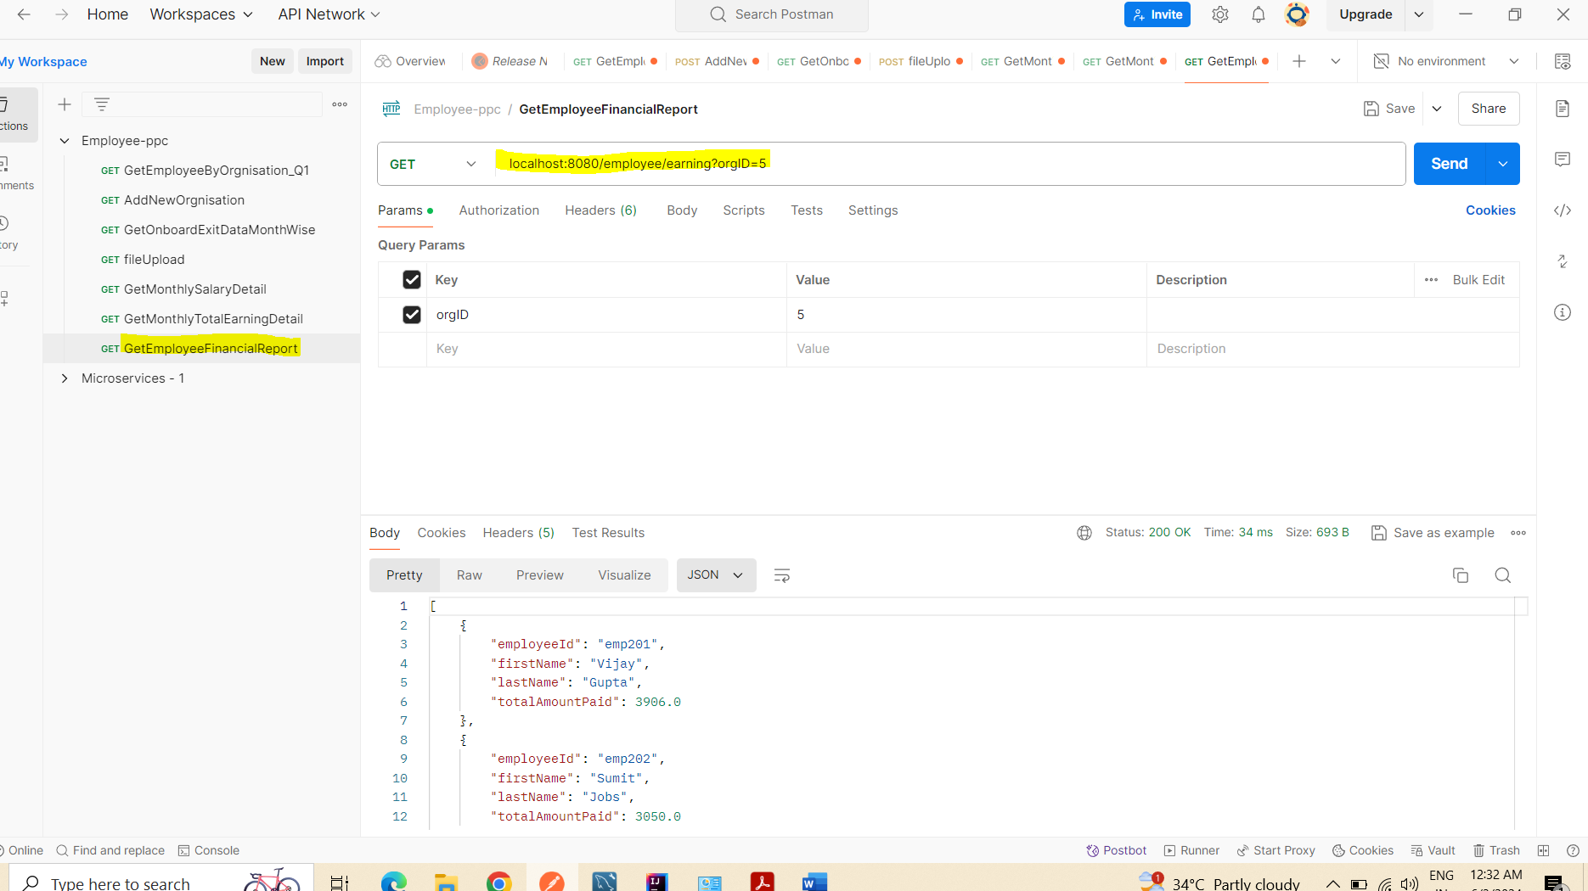

Q5. Monthly amount released in following format - Month, Total Amount (Salary + Bonus + REIMBURSEMENT), Total employees

Ans5 - For month wise total amount (Salary + Bouns + Reimbursement) data for an organization, hit a GET request with organization ID. Please see below screenshot –

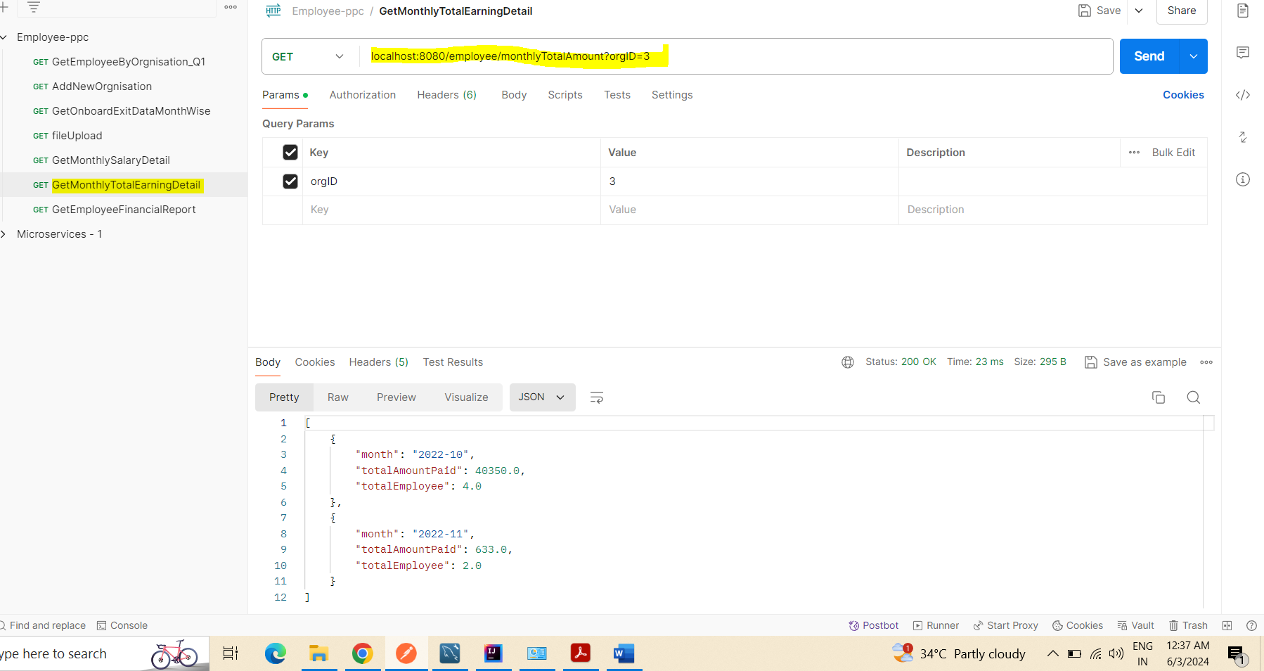

Q6. Yearly financial report in the following format - Event, Emp Id, Event Date, Event value

Ans6 – For Event financial report (total amount paid to employee) data for an employees’ present in an organization, hit a GET request with organization ID. Please see below screenshot –

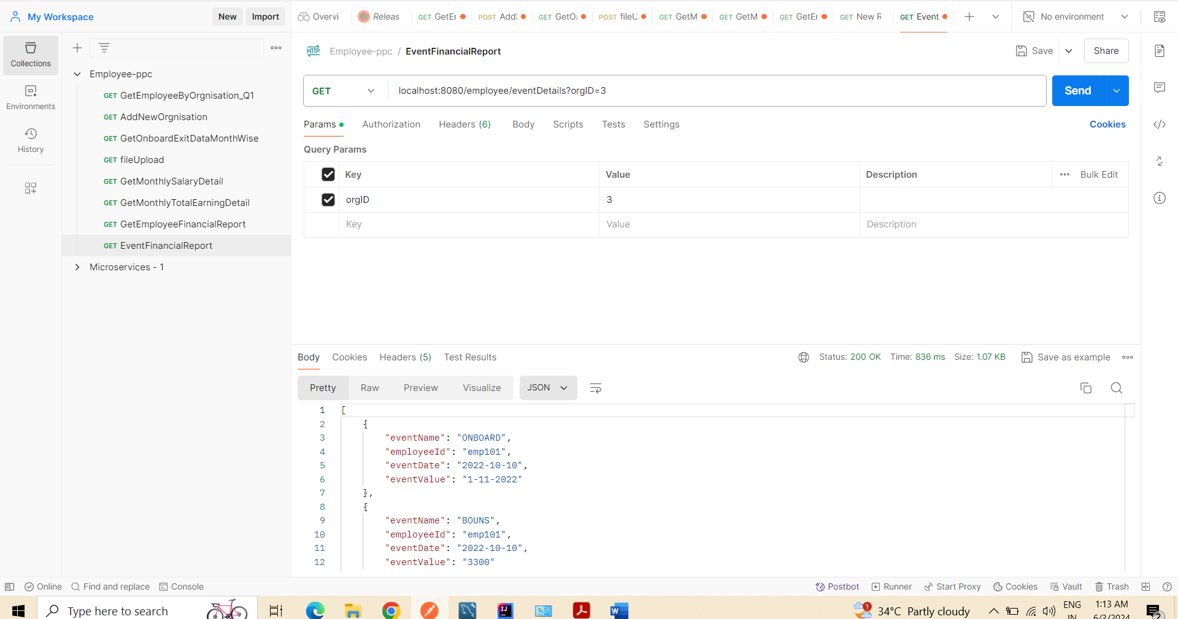

Note:

1.Input file name must be orgnisationName.txt/csv

2. Add orgnisation in orgnisation table and get the orgId before doing another query. (This will be used in all other query)